**Objective & Scope of the Project**

**Objectives:**

The primary objective of our automated timetable generator project is to significantly enhance the efficiency of the timetable creation process within educational institutions. By leveraging automation, we aim to reduce the time and effort required for generating schedules compared to traditional manual methods. Another key objective is the optimization of resource utilization, ensuring effective use of classrooms, teachers, and other resources. The goal is to minimize conflicts and maximize efficiency in the allocation of these resources, ultimately leading to a more streamlined and effective scheduling process. Additionally, our objective includes providing a flexible and adaptable solution capable of accommodating changes in course offerings, room availability, and teacher preferences with minimal disruptions. We also aim to minimize conflicts in scheduling through the development of advanced algorithms and logic to handle issues such as overlapping classes, room shortages, and teacher unavailability. Lastly, a user-friendly interface is a key focus, designed to empower administrators with easy data input and comprehensibility of generated timetables.

**Scope:**

Our timetable generator project is specifically designed for deployment in academic institutions, including schools, colleges, and universities. The scope encompasses the creation of timetables for regular classes, exams, and other scheduled events within the academic calendar. Users targeted by our system include administrators responsible for timetable creation and modification. Within the project's scope is the management of data related to courses, teachers, classrooms, and other relevant information necessary for scheduling. The automation levels can vary from partial to full automation of the timetable creation process, providing administrators with the flexibility to incorporate their preferences and constraints. Reporting features, generating reports for administrators, and notifications for any conflicts or issues in the timetable are also within the scope. The project allows for integration with existing systems or databases holding pertinent information, such as student and teacher databases. The development will occur using specific programming languages and frameworks, as decided upon during project planning. Rigorous testing procedures are integral to the project, ensuring the accuracy and reliability of the timetable generator. By defining these objectives and scope elements, we aim to provide clarity for all project team members and stakeholders, fostering a shared understanding of the project's goals and boundaries

**Theoretical Background of Project**

**1. Timetabling Problem:** The timetabling problem is a multifaceted challenge encountered in educational institutions, involving the efficient allocation of resources like classrooms, teachers, and time slots to various courses and activities. It requires careful consideration of constraints to produce a feasible and optimized timetable.

**2. Constraint Satisfaction Problems (CSP):** The timetabling problem can be effectively modeled as a Constraint Satisfaction Problem (CSP). CSP involves defining a set of variables, domains, and constraints to find a solution that satisfies all specified conditions. In the context of timetabling, these constraints could include room availability, teacher preferences, and avoiding scheduling conflicts.

**3. Soft and Hard Constraints:** Timetabling systems often deal with both soft and hard constraints. Hard constraints are non-negotiable conditions that must be satisfied for a timetable to be valid, such as avoiding room conflicts. Soft constraints, on the other hand, represent preferences that can be violated to some extent without rendering the timetable invalid. Striking a balance between these types of constraints is crucial for creating practical and acceptable timetables.

**4. User Preferences and Human Factors:** Understanding and incorporating user preferences and human factors is paramount in developing a successful timetable generator. This involves considering the needs and preferences of administrators, teachers, and students. User-friendly interfaces, intuitive design, and the ability to adapt to user preferences contribute to the usability and effectiveness of the automated timetable generator. Taking into account the human element ensures that the generated timetables align with real-world requirements and are more readily accepted by users.

**Problem Definition: Automated Timetabling in Educational-Institutions**

The automated timetabling problem in educational institutions involves the complex task of efficiently scheduling courses, classes, and resources within a specified timeframe. This optimization challenge arises from the need to allocate various resources such as classrooms, teachers, and time slots while adhering to a set of constraints and satisfying user preferences. The primary objective is to generate a timetable that not only meets the academic requirements of the institution but also minimizes conflicts, optimizes resource utilization, and aligns with user preferences.

In essence, the problem entails creating a timetable that balances the allocation of courses to appropriate time slots and classrooms, considering the availability and preferences of teachers. This process must adhere to both hard constraints, such as avoiding scheduling conflicts and meeting specific resource limitations, and soft constraints, which encompass user preferences and preferences that can be flexibly accommodated.

The automated timetabling problem is a classic example of a Constraint Satisfaction Problem (CSP), where the goal is to find a feasible solution within a defined set of constraints. The challenge extends to incorporating both rigid constraints that must be satisfied for the timetable to be valid and softer constraints that allow for a degree of flexibility based on user preferences.

Additionally, the problem involves addressing the human factor, recognizing the importance of user preferences and practical considerations. A successful automated timetable generator should be user-friendly, taking into account the needs and preferences of administrators, teachers, and students. Balancing the optimization objectives with the human element ensures the generated timetables are not only efficient and conflict-free but also widely accepted and practical within the educational institution's context.

**System Analysis & Design**

**1. System Analysis:**

* **Requirements Gathering:**
  + Conduct thorough discussions with stakeholders, including administrators, teachers, and other users, to identify and document their requirements for the automated timetable generator.
  + Identify key features, constraints, and preferences that must be considered during the scheduling process.
* **Data Collection and Analysis:**
  + Examine existing data related to courses, teachers, classrooms, and other scheduling parameters.
  + Evaluate the quality and format of available data, identifying any gaps or inconsistencies that need resolution.
* **Functional and Non-functional Requirements:**
  + Define the functional requirements, specifying the features and capabilities the timetable generator must have.
  + Identify non-functional requirements, such as performance, scalability, and security considerations.
* **Use Case Analysis:**
  + Develop use cases to illustrate the interaction between users and the system.
  + Define scenarios that depict how different users will interact with the automated timetable generator.

**2. System Design:**

* **Architecture Design:**
  + Define the overall architecture of the system, including its components, modules, and their interactions.
  + Choose an appropriate architecture that aligns with the project's objectives and scalability requirements.
* **Database Design:**
  + Design the database schema to store information about courses, teachers, classrooms, and the generated timetables.
  + Ensure efficient data retrieval and update operations to support the scheduling process.
* **User Interface Design:**
  + Create a user-friendly interface that allows administrators to input data easily and interpret generated timetables.
  + Incorporate intuitive design principles to enhance user experience.
* **Algorithmic Design:**
  + Specify the algorithms and logic to be used for timetable generation.
  + Consider optimization techniques to address conflicts, constraints, and preferences in an efficient manner.
* **Security and Access Control:**
  + Implement security measures to protect sensitive data.
  + Define access control mechanisms to ensure that only authorized users can perform specific actions.
* **Integration and Testing:**
  + Plan for integration with other systems or databases as needed.
  + Develop a comprehensive testing strategy, including unit testing, integration testing, and system testing, to ensure the reliability and accuracy of the timetable generator.

**3. Iterative Development:**

* **Prototyping and Feedback:**
  + Develop prototypes or minimum viable products to gather feedback from users.
  + Iterate on the design based on user input, addressing any identified issues or enhancements.
* **Agile Development Practices:**
  + Embrace agile development practices to facilitate flexibility and adaptability throughout the development process.
  + Regularly review and adjust the project plan based on evolving requirements and feedback.

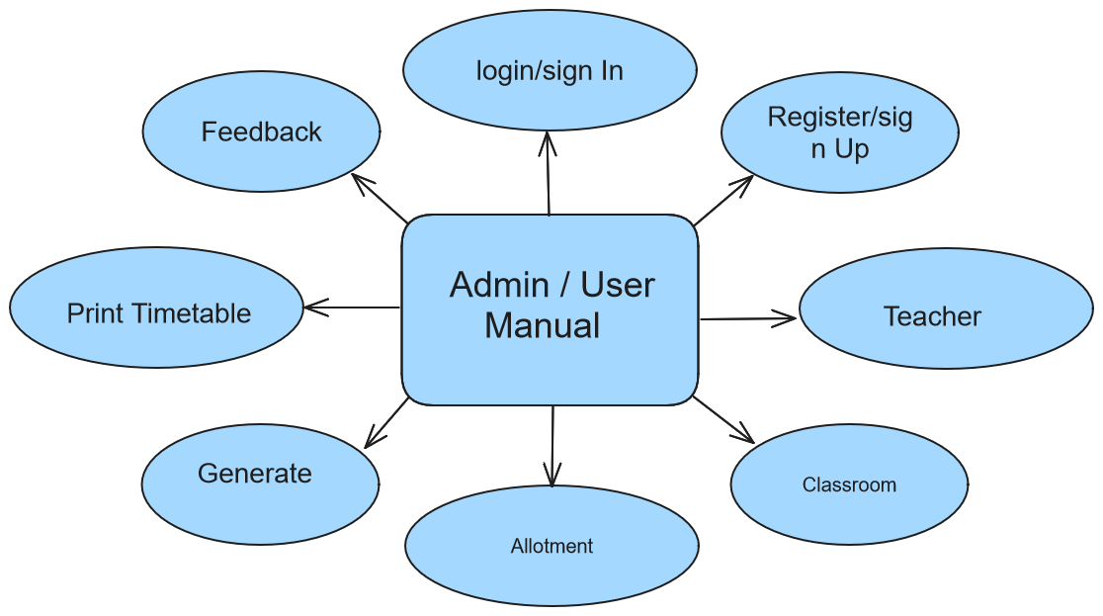

**System Planning (PERT - Chart)**

The system planning for the Automated Timetable Generator unfolds in a Program Evaluation and Review Technique (PERT) chart, outlining a series of sequential tasks and their dependencies. Kicking off with defining project objectives and identifying stakeholders, the plan progresses through essential phases like requirements gathering, use case analysis, and architectural design.

The subsequent steps include user interface design, algorithmic planning, and integration strategies, laying the groundwork for the development phase. Here, tasks like prototyping, testing, and agile iterations run concurrently, facilitating continuous alignment with project goals. Documentation efforts, integral to the process, run parallel to the development phase.

The deployment task, contingent on successful testing, leads to user training, monitoring and maintenance planning, and eventual project review and closure. The PERT chart serves as a visual guide, aiding project managers in monitoring progress, identifying bottlenecks, and allocating resources effectively.

Emphasizing task interdependencies, the chart highlights the logical sequence of activities. For example, user interface design precedes algorithmic planning, ensuring a well-defined interface before diving into complex algorithms. The iterative nature of tasks, such as prototyping and agile iterations, showcases the project's adaptability to evolving requirements.

In essence, the PERT chart encapsulates strategic planning, providing a concise roadmap for the systematic development and implementation of the Automated Timetable Generator.

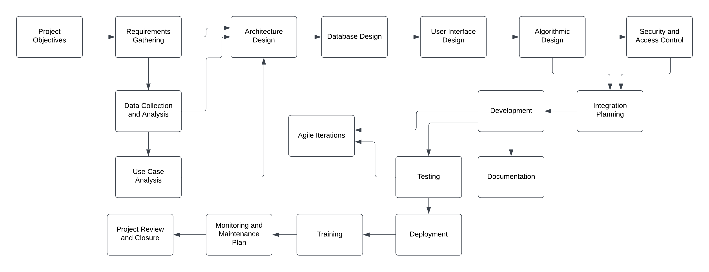

*fig.*1. PERT Chart

**Methodology Adopted:**

The development methodology chosen for the Automated Timetable Generator project is an iterative and incremental approach, blending aspects of both Agile and Waterfall methodologies. The iterative nature allows for flexibility, adaptation to changing requirements, and continuous improvement throughout the development lifecycle. Simultaneously, incremental releases ensure that tangible features are delivered at the end of each iteration, providing stakeholders with the opportunity to provide feedback and shape the ongoing development process.

The project team follows the Scrum framework within the Agile methodology, conducting regular sprint planning, daily stand-ups, sprint reviews, and retrospectives. This facilitates efficient collaboration, ensures continuous feedback from stakeholders, and promotes the incremental development of the system.

**System Implementation:**

The system implementation involves the utilization of a local development environment for ease of testing and modification. XAMPP/WAMPP serves as the web server, providing a platform-independent environment for running PHP scripts. Python scripts are employed for algorithmic processing during timetable generation.

The system's backend relies on a MySQL relational database to store and manage data related to courses, teachers, classrooms, and timetable details. The use of HTML and CSS enables the creation of user-friendly and visually appealing interfaces. Java is employed for advanced processing algorithms, particularly in the algorithm for timetable generation.

**Details of Hardware and Software Used:**

*Hardware:*

* A standard computer system with a minimum configuration of 4GB RAM, a multi-core processor, and sufficient storage to accommodate the development environment and database.

*Software:*

1. **XAMPP/WAMPP:** A cross-platform web server solution that includes Apache, MySQL, PHP, and Perl for local development.
2. **Python:** Utilized for scripting, particularly in the algorithmic processing for timetable generation.
3. **MySQL:** The relational database management system employed for efficient storage, retrieval, and management of scheduling data.
4. **HTML and CSS:** Used for frontend development to create user-friendly interfaces.
5. **Java:** Applied for the implementation of advanced processing algorithms.

The project leverages a combination of these tools and technologies to ensure cross-platform compatibility, efficient data management, and a robust user interface, contributing to the overall success of the Automated Timetable Generator.

**System Maintenance and Evaluation for Automated Time-table Generator**

**System Maintenance:**

Maintenance is a crucial aspect of ensuring the continuous functionality, reliability, and adaptability of the Automated Timetable Generator. It involves several key activities:

1. **Bug Fixing:**
   * Regularly monitor for any reported or identified bugs.
   * Implement timely bug fixes to enhance system stability.
2. **Updates and Upgrades:**
   * Periodically release updates or upgrades to introduce new features and improvements.
   * Ensure backward compatibility to minimize disruptions for existing users.
3. **Security Patches:**
   * Stay vigilant about potential security vulnerabilities.
   * Apply security patches promptly to protect sensitive data.
4. **User Feedback Integration:**
   * Gather feedback from users on an ongoing basis.
   * Integrate valuable user insights to enhance user experience and address user concerns.
5. **Database Maintenance:**
   * Implement regular database maintenance routines.
   * Optimize database performance and ensure data integrity.
6. **Documentation Updates:**
   * Keep user manuals and technical documentation up-to-date.
   * Reflect changes, new features, and improvements in the documentation.
7. **Monitoring and Analytics:**
   * Set up monitoring tools to track system performance.
   * Utilize analytics to identify usage patterns and potential areas for improvement.
8. **User Training:**
   * Provide additional training sessions for new features or major updates.
   * Ensure that users are aware of any changes that might affect their interaction with the system.

**System Evaluation:**

Evaluating the Automated Timetable Generator involves assessing its performance, efficiency, and user satisfaction:

1. **Performance Metrics:**
   * Measure system response times, especially during peak usage.
   * Evaluate the efficiency of the timetable generation algorithm.
2. **Reliability and Uptime:**
   * Track system uptime and availability.
   * Address any downtime promptly to minimize disruptions.
3. **User Satisfaction Surveys:**
   * Conduct periodic surveys to gather user feedback.
   * Evaluate user satisfaction with the system's features and usability.
4. **Usage Analytics:**
   * Analyze usage patterns and trends.
   * Identify popular features and areas for potential improvement.
5. **Compliance and Security Audits:**
   * Regularly conduct audits to ensure compliance with relevant standards.
   * Verify that security measures are robust and up-to-date.
6. **Cost-Benefit Analysis:**
   * Assess the overall cost of system maintenance against the benefits it provides.
   * Evaluate the return on investment and the impact on operational efficiency.
7. **Scalability and Future-Proofing:**
   * Evaluate the system's scalability to accommodate growth.
   * Assess its adaptability to emerging technologies and changing requirements.
8. **Alignment with Objectives:**
   * Review the system's alignment with the initial project objectives.
   * Ensure that it continues to meet the needs of educational institutions effectively.

**Cost and Benefit Analysis for Automated Timetable Generator**

**Cost Analysis:**

1. **Development Costs:**
   * *Personnel:* Expenses related to the salaries of developers, designers, and project managers involved in the development process.
   * *Tools and Software:* Costs associated with acquiring licenses for development tools, software, and databases.
2. **Infrastructure Costs:**
   * *Hardware:* Investment in servers, computers, and other hardware required for development and testing.
   * *Software Licenses:* Cost of software licenses for server operating systems, development environments, and other tools.
3. **Training Costs:**
   * *User Training:* Costs related to training administrators, teachers, and users on how to use the Automated Timetable Generator effectively.
4. **Maintenance and Support Costs:**
   * *Bug Fixes and Updates:* Expenses associated with fixing bugs, releasing updates, and maintaining the system's overall health.
   * *User Support:* Cost of providing ongoing user support to address queries and issues.
5. **Deployment Costs:**
   * *Server Hosting:* Expenses related to hosting the system on servers for real-world usage.
   * *Network Infrastructure:* Costs associated with ensuring a reliable and secure network infrastructure.
6. **Security Costs:**
   * *Security Measures:* Investment in security tools, encryption protocols, and other measures to protect sensitive data.

**Benefit Analysis:**

1. **Time and Labor Savings:**
   * *Reduction in Manual Effort:* A significant benefit arises from the automation of the timetable generation process, leading to substantial time savings for administrators and educators.
2. **Efficiency and Optimization:**
   * *Optimized Resource Allocation:* The system's ability to optimize the allocation of teachers, classrooms, and time slots results in a more efficient use of resources.
3. **Reduced Scheduling Conflicts:**
   * *Minimization of Conflicts:* The Automated Timetable Generator minimizes scheduling conflicts, reducing disruptions and creating a more seamless academic environment.
4. **Improved User Experience:**
   * *User-Friendly Interface:* The creation of a user-friendly interface enhances the experience for administrators, teachers, and users, making the system more accessible and intuitive.
5. **Enhanced Decision-Making:**
   * *Data-Driven Insights:* The system's capability to provide multiple views and analytics contributes to informed decision-making by educational institutions.
6. **Adaptability to Change:**
   * *Flexibility and Adaptability:* The system's adaptability to various educational institutions and changing requirements offers a long-term benefit.
7. **Reduced Error Rates:**
   * *Error-Free Timetables:* The implementation of advanced algorithms and logic results in a significant reduction in scheduling errors, contributing to the reliability of the generated timetables.
8. **Improved Academic Environment:**
   * *Streamlined Processes:* The overall benefit includes the creation of a more organized and streamlined academic environment, positively impacting the institution's reputation and effectiveness.

**Return on Investment (ROI):**

The return on investment is calculated by subtracting the total costs from the total benefits and dividing the result by the total costs:

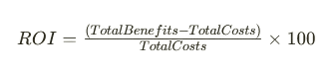

**Conclusion:**

The Automated Timetable Generator yields a strong return on investment, markedly enhancing timetable efficiency, reducing manual efforts, and improving the academic experience. Initial costs are surpassed by long-term benefits, establishing the system as a valuable asset for institutions in need of an automated scheduling solution.

**Detailed Life Cycle of the Project**

The detailed life cycle of the Automated Timetable Generator project encompasses several key phases, each contributing to the successful development, implementation, and maintenance of the system.

1. **Initiation:**
   * *Objective Definition:* Clearly define the project objectives, scope, and expected outcomes.
   * *Stakeholder Identification:* Identify and engage stakeholders, including administrators, teachers, and users.
   * *Feasibility Study:* Assess the technical, operational, and financial feasibility of the project.
2. **Planning:**
   * *Requirements Gathering:* Conduct comprehensive sessions to gather and document functional and non-functional requirements.
   * *Data Collection and Analysis:* Examine existing data related to courses, teachers, and classrooms. Evaluate data quality.
   * *Use Case Analysis:* Develop use cases illustrating user interactions and scenarios.
   * *System Design:* Design the overall architecture, database schema, user interface, and algorithmic components.
   * *Security and Access Control Design:* Establish security measures and access control mechanisms.
3. **Development:**
   * *Coding:* Implement the designed components using programming languages such as Python, Java, HTML, CSS, and PHP.
   * *Database Implementation:* Set up and populate the MySQL database with scheduling-related information.
   * *Prototyping:* Develop prototypes to gather user feedback iteratively.
   * *Testing:* Conduct unit testing, integration testing, and system testing to ensure the reliability of the system.
4. **Deployment:**
   * *Server Setup:* Deploy the system on a server, ensuring compatibility with the chosen hosting environment.
   * *User Training:* Conduct training sessions for administrators, teachers, and users to ensure effective system utilization.
   * *Data Migration:* If applicable, migrate existing data to the new system.
5. **Monitoring and Maintenance:**
   * *Monitoring:* Set up monitoring tools to track system performance and usage patterns.
   * *Maintenance:* Address and fix any reported issues promptly. Release updates and upgrades as needed.
   * *User Support:* Provide ongoing user support to address queries and issues.
6. **Evaluation:**
   * *Performance Metrics:* Measure system response times, uptime, and overall performance.
   * *User Feedback Analysis:* Gather and analyze user feedback to identify areas for improvement.
   * *Compliance Audits:* Conduct audits to ensure compliance with data privacy and security standards.
7. **Documentation:**
   * *User Manuals:* Update user manuals and technical documentation to reflect changes and new features.
   * *System Documentation:* Maintain comprehensive documentation covering system functionalities, algorithms, and security measures.
8. **Project Review and Closure:**
   * *Review:* Conduct a thorough review of the project's overall success, considering objectives, user satisfaction, and performance metrics.
   * *Closure:* Officially close the project, ensuring all loose ends are tied, and stakeholders are informed.

Throughout this life cycle, an iterative and agile approach is embraced, allowing for flexibility and adaptation to evolving requirements and user feedback. Regular communication with stakeholders, continuous testing, and documentation updates contribute to the project's success and sustainability

**ER-Diagram for the project:**

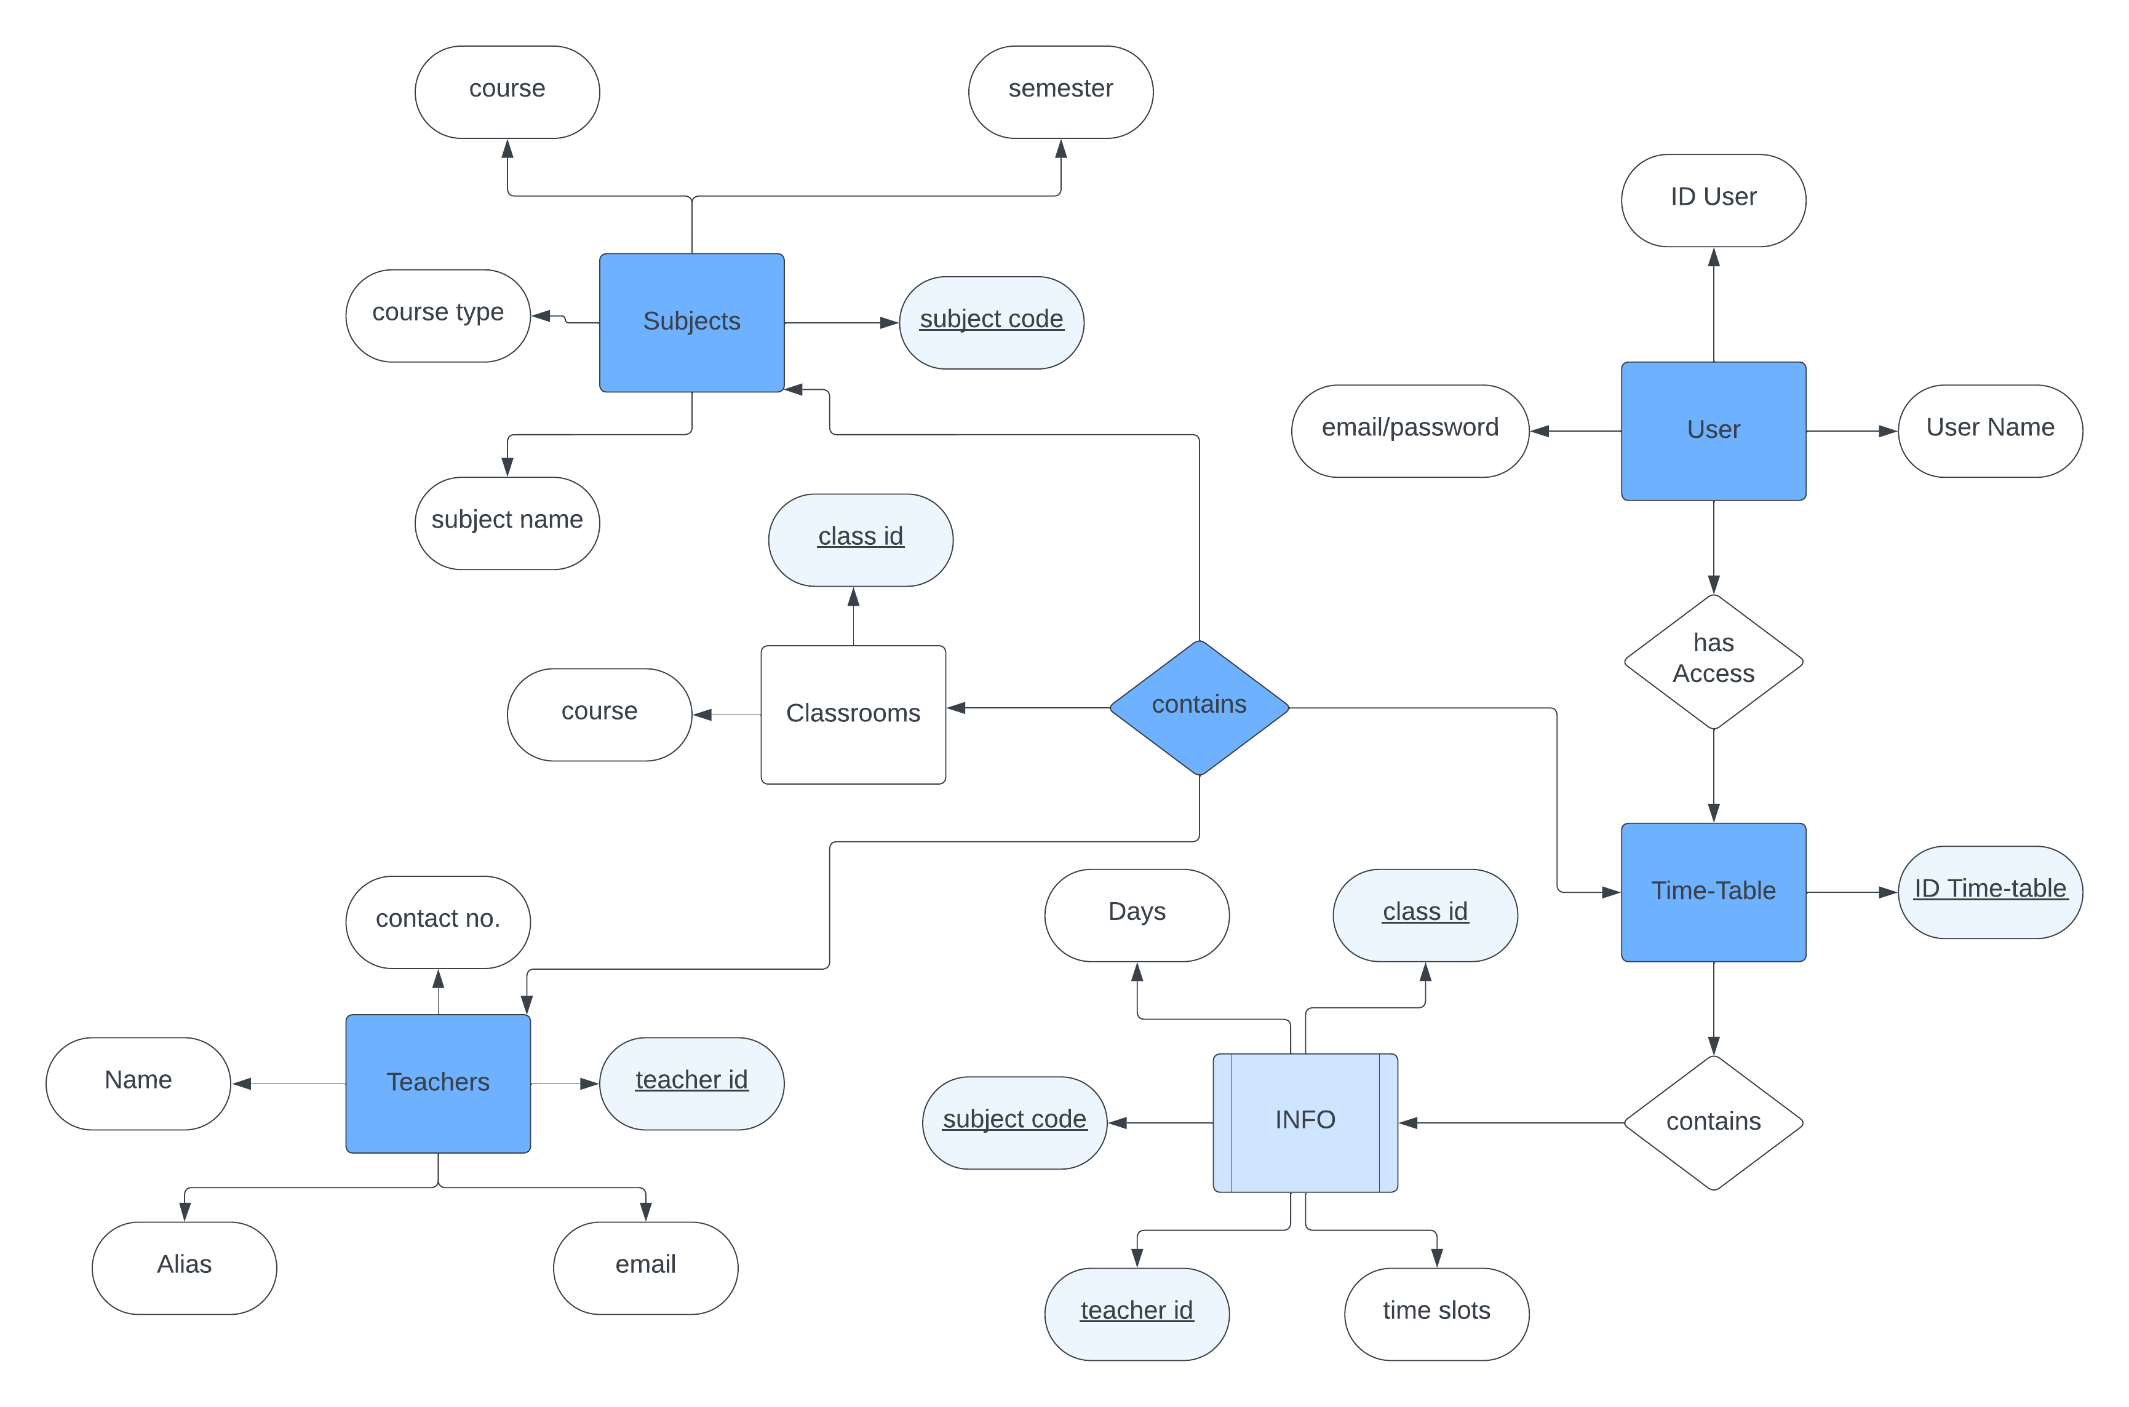

*fig.2.*E-R Diagram

**Data-Flow-Diagram for the project:**

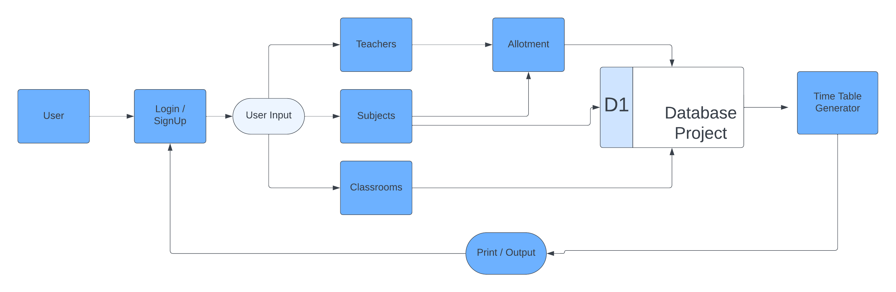

***fig .3.*** Data Flow Diagram

**Input and output screen design:**

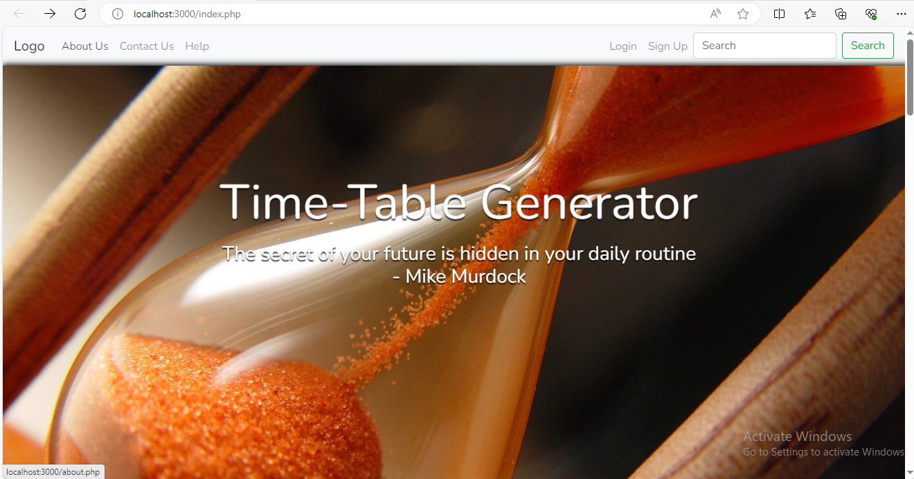**Home :-**

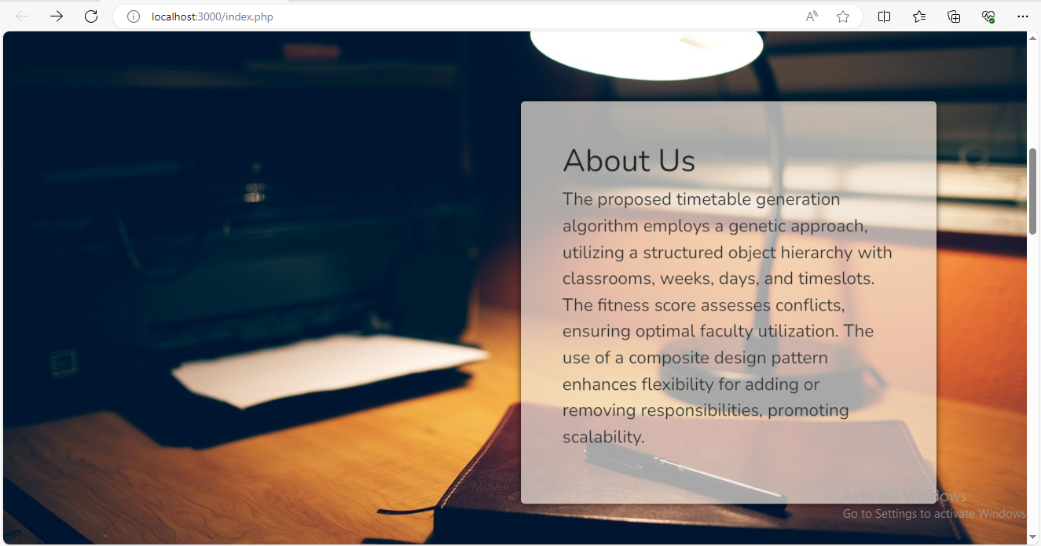**About Us :-**

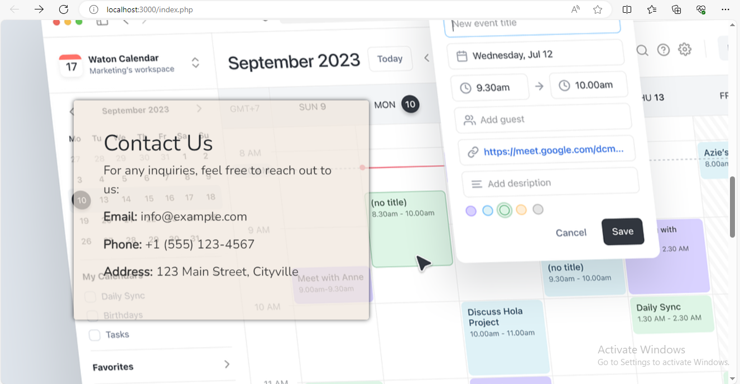**Contact Us :-**

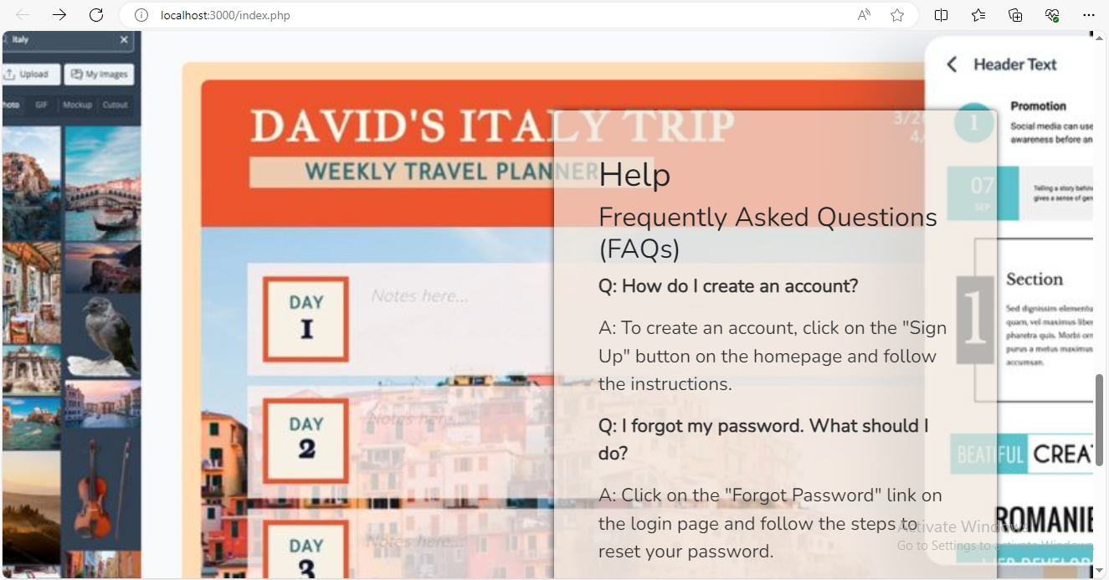**Help :-**

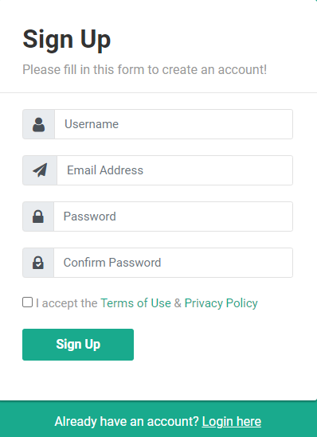**Sign Up :-**

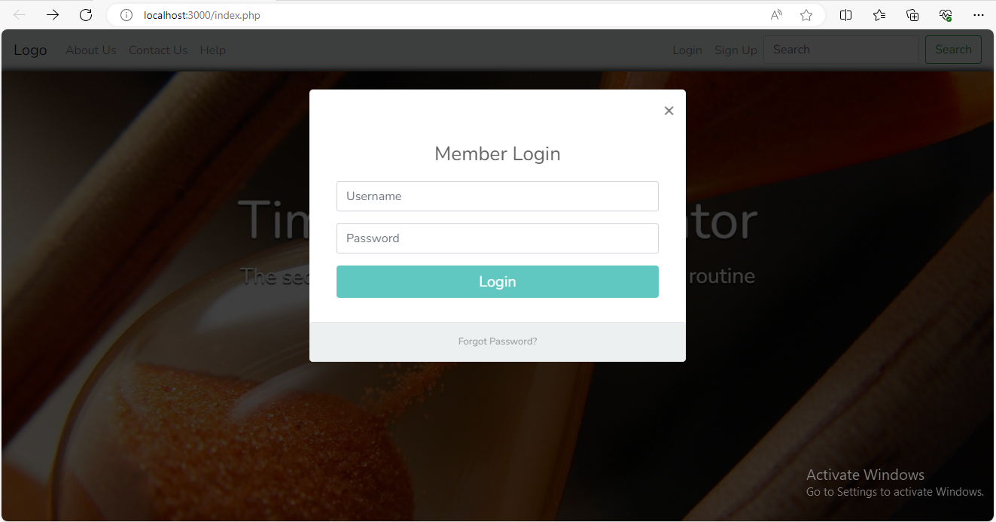**Login:-**

**Teachers:-** 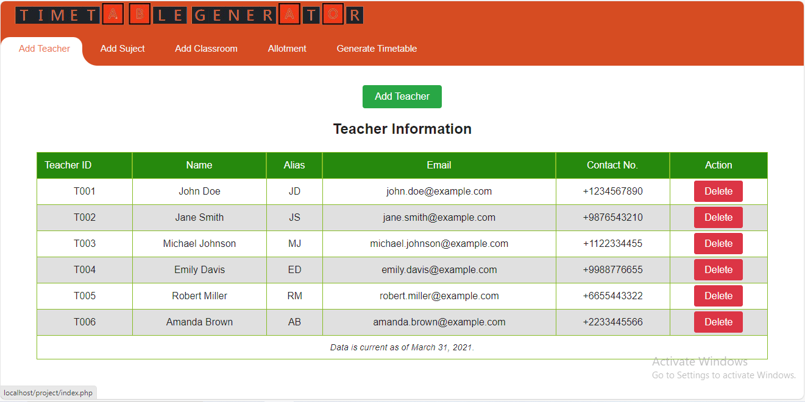

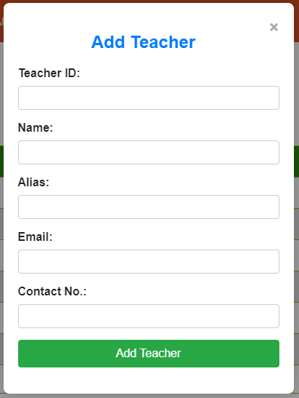**Add teacher:-**

**Subjects:-** 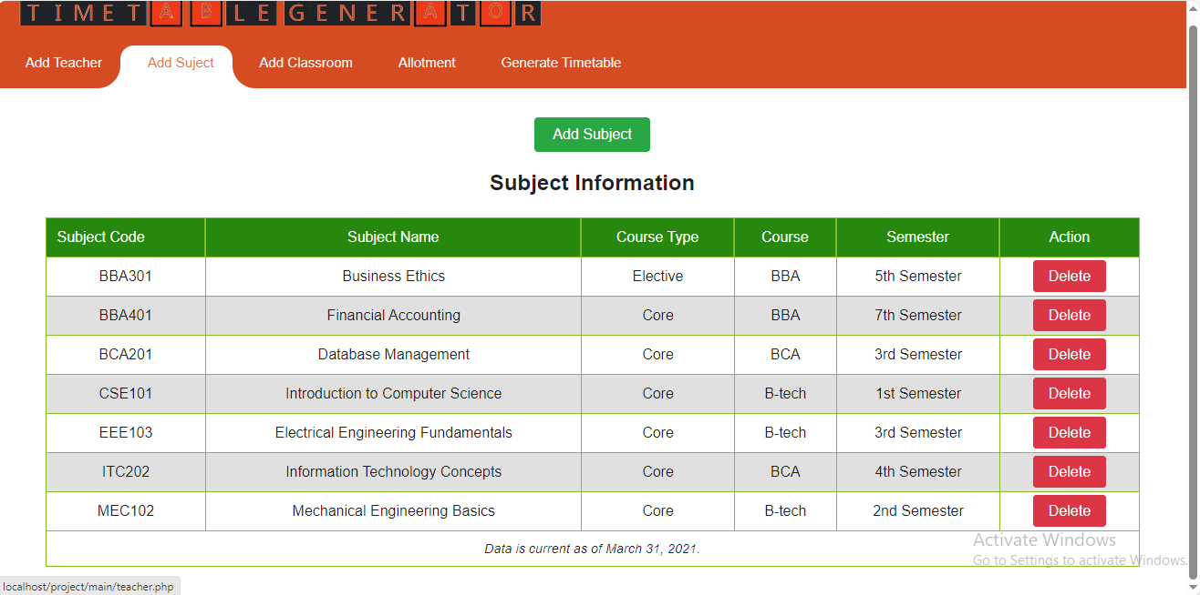

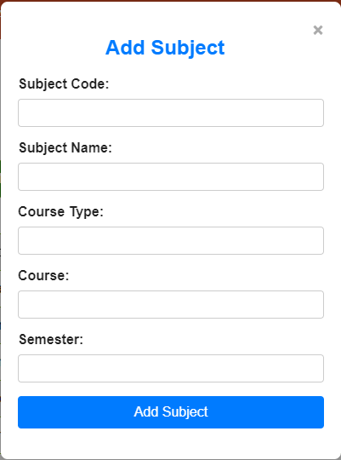**Add subject :-**

**Classrooms:-**

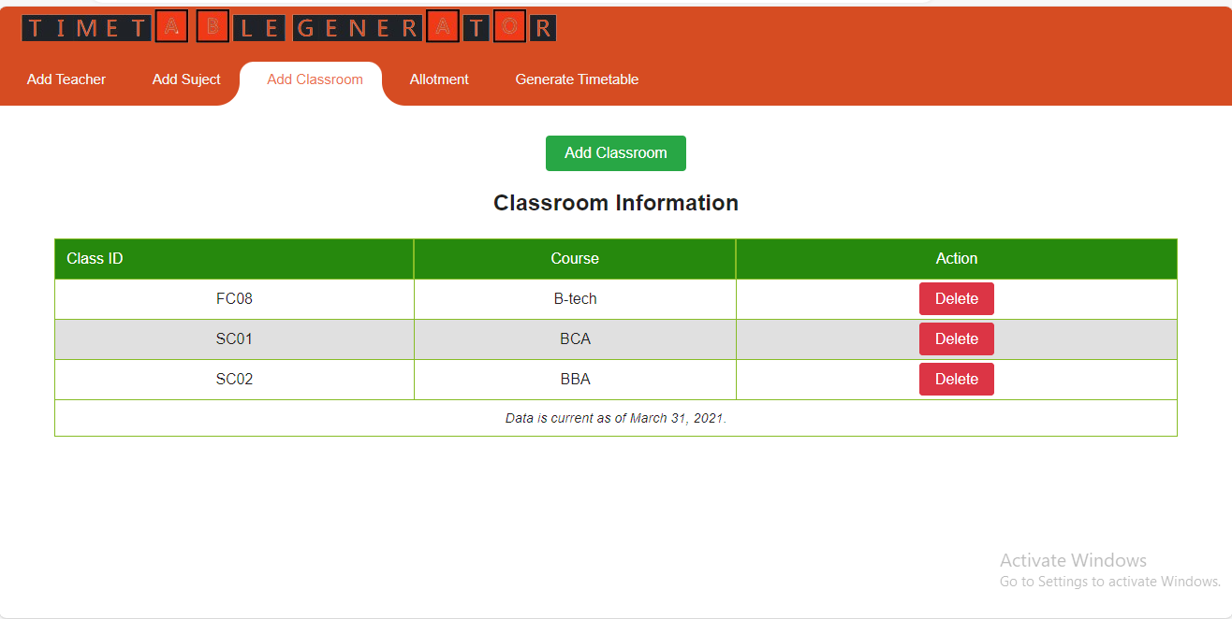

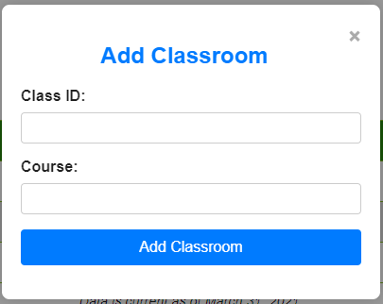**Add Classroom:-**

**Allotment:**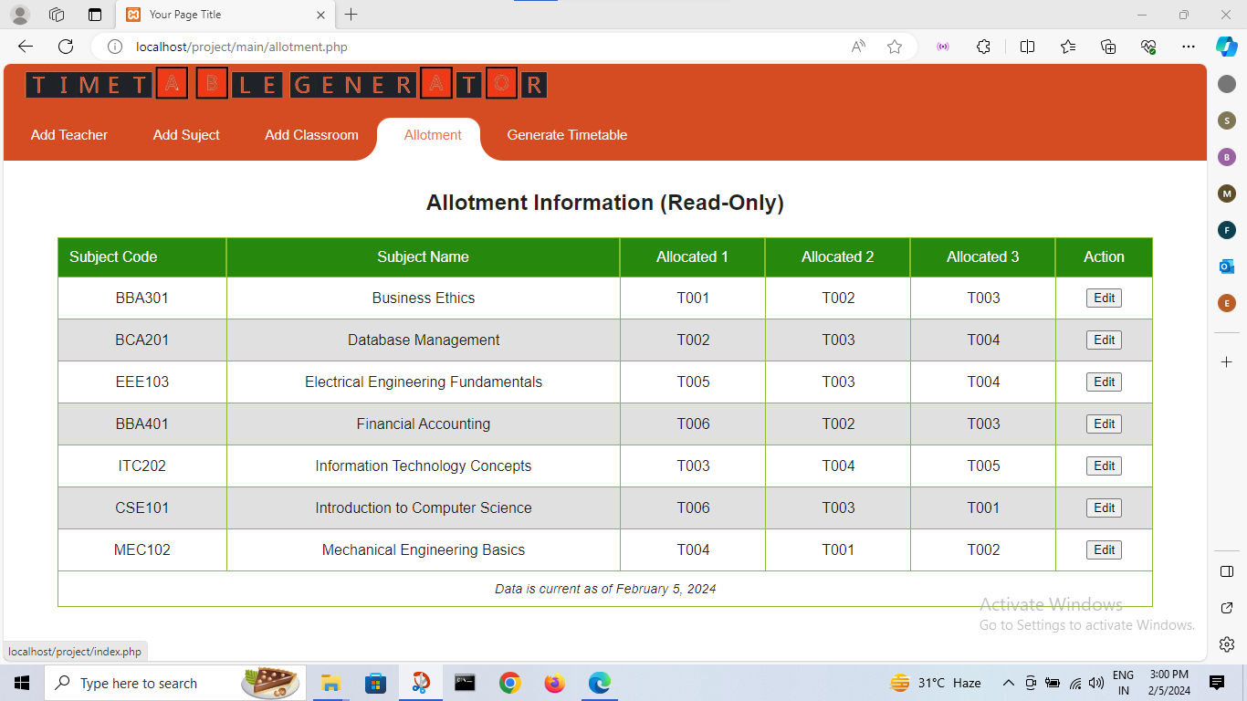

**Edit allotment:-**

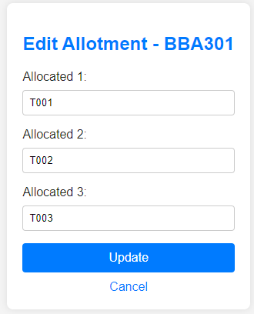

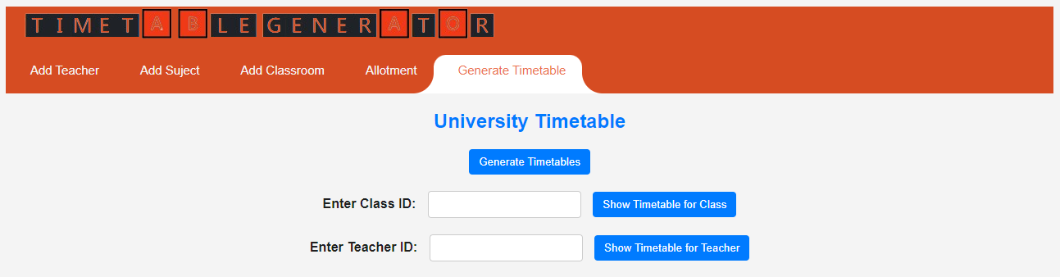**Generate Timetable:-**

**Show Time-table( Classes ):-**

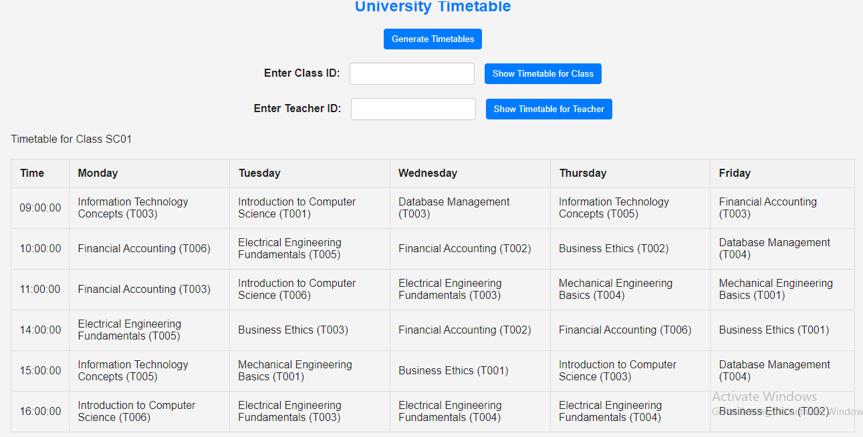

**Show Time-table ( Teachers ):-**

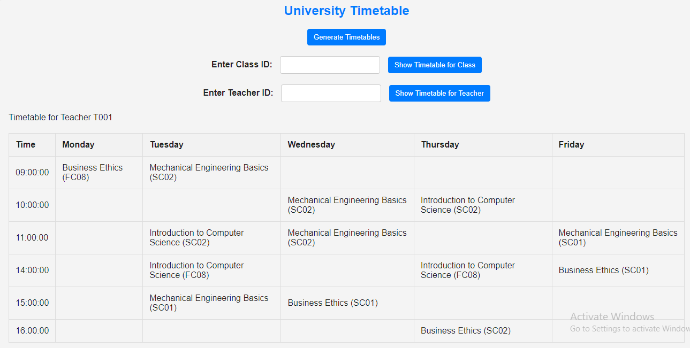**Print / Save :-**

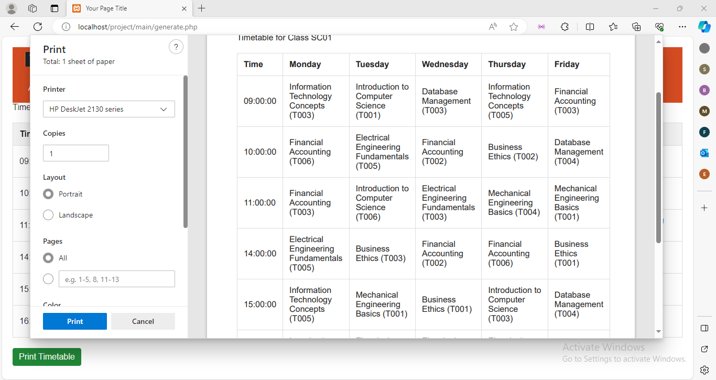

**Process involved:**

The Automated Timetable Generator involves several key processes to efficiently generate and manage timetables for educational institutions. Here's an overview of the main processes involved:

1. **System Initialization:**
   * **Description:** This process involves initializing the Automated Timetable Generator system, ensuring that all necessary components and settings are in place for effective operation.
   * **Tasks:**
     + Load system configurations.
     + Set up initial user accounts and permissions.
     + Configure system preferences.
2. **User Management:**
   * **Description:** User management encompasses the creation, modification, and deletion of user accounts, assigning appropriate roles and access rights to administrators, teachers, and other stakeholders.
   * **Tasks:**
     + Add new users.
     + Modify user profiles.
     + Manage user roles and permissions.
3. **System Configuration:**
   * **Description:** Configure the system settings, including defining academic parameters, term dates, and other institutional details.
   * **Tasks:**
     + Set academic term parameters.
     + Define school hours and breaks.
     + Configure other relevant system settings.
4. **Input Constraints Definition:**
   * **Description:** Collect and input various constraints that influence timetable generation, such as teacher availability, room allocation preferences, and subject priorities.
   * **Tasks:**
     + Input teacher availability.
     + Define room allocation preferences.
     + Specify subject priorities.
5. **Timetable Generation:**
   * **Description:** This core process involves applying algorithms and logic to generate an optimized timetable based on the input constraints and system configurations.
   * **Tasks:**
     + Utilize scheduling algorithms to allocate subjects to time slots.
     + Optimize teacher, room, and subject assignments.
     + Resolve scheduling conflicts.
6. **Review and Validation:**
   * **Description:** Review and validate the generated timetable to ensure it adheres to academic requirements, preferences, and constraints.
   * **Tasks:**
     + Review the generated timetable.
     + Validate against input constraints.
     + Make adjustments if necessary.
7. **Timetable Publication:**
   * **Description:** Publish the final, validated timetable for access by administrators, teachers, and students.
   * **Tasks:**
     + Make the timetable available on the system.
     + Notify stakeholders of the timetable release.
8. **Feedback Collection:**
   * **Description:** Gather feedback from users about the generated timetable to identify areas for improvement or adjustment.
   * **Tasks:**
     + Collect feedback from teachers and administrators.
     + Analyze feedback for system enhancements.
9. **System Maintenance:**
   * **Description:** Perform ongoing maintenance tasks to address system issues, apply updates, and ensure the continued smooth operation of the Automated Timetable Generator.
   * **Tasks:**
     + Fix reported bugs.
     + Release updates with new features or improvements.
     + Monitor system performance.
10. **Reporting and Analytics:**
    * **Description:** Generate reports and analytics based on the generated timetable data to provide insights into resource utilization, scheduling patterns, and potential improvements.
    * **Tasks:**
      + Generate utilization reports for classrooms and teachers.
      + Analyze scheduling patterns.
      + Identify optimization opportunities.

These processes collectively contribute to the successful operation of the Automated Timetable Generator, streamlining the scheduling process and enhancing the overall academic experience for educational institutions. The iterative nature of the system allows for continuous improvement and adaptation to changing requirements.

**Methodology used for testing**

The testing methodology for the Automated Timetable Generator involves a systematic approach to ensure the reliability, functionality, and performance of the system. Here's an overview of the methodology used for testing:

1. **Requirements Analysis:**
   * Understand the functional and non-functional requirements of the system.
   * Identify testable features and functionalities based on the requirements.
2. **Test Planning:**
   * Develop a comprehensive test plan outlining the objectives, scope, resources, and timelines for testing.
   * Define test scenarios, test cases, and test data to be used during testing.
3. **Unit Testing:**
   * Test individual units or components of the system in isolation to verify their correctness and functionality.
   * Use testing frameworks and tools to automate unit tests wherever possible.
   * Ensure code coverage to identify areas that are not adequately tested.
4. **Integration Testing:**
   * Verify the interaction between different modules or components of the system.
   * Test data flow and communication between integrated parts to ensure seamless integration.
   * Conduct both top-down and bottom-up integration testing approaches as necessary.
5. **System Testing:**
   * Test the system as a whole to validate its compliance with requirements and specifications.
   * Perform functional testing to verify if the system meets user expectations and performs as intended.
   * Conduct non-functional testing to assess aspects like performance, usability, security, and reliability.
6. **Regression Testing:**
   * Repeatedly test the system after changes to ensure that existing functionalities are not affected.
   * Automate regression tests to streamline the testing process and ensure consistency.
7. **User Acceptance Testing (UAT):**
   * Involve end-users, including administrators, teachers, and students, to validate the system against their expectations and requirements.
   * Gather feedback and incorporate necessary changes based on user input.
8. **Performance Testing:**
   * Assess the system's performance under different load conditions to ensure scalability and stability.
   * Conduct stress testing, load testing, and endurance testing to identify performance bottlenecks and optimize system resources.
9. **Security Testing:**
   * Evaluate the system's security measures to identify vulnerabilities and ensure the protection of sensitive data.
   * Perform penetration testing, vulnerability scanning, and security audits to assess the system's resilience to potential threats.
10. **Documentation and Reporting:**
    * Document test cases, test results, and any defects found during testing.
    * Generate test reports summarizing the testing process, outcomes, and recommendations for improvement.

**Automated Timetable Generator Test Report**

**Executive Summary:**

The testing phase for the Automated Timetable Generator was conducted to ensure the reliability, functionality, and performance of the system. The testing process involved unit testing, integration testing, system testing, regression testing, user acceptance testing (UAT), and specialized testing for performance and security aspects.

**Testing Objectives:**

1. Validate the system's compliance with functional and non-functional requirements.
2. Identify and rectify defects or inconsistencies in the system.
3. Ensure the system's performance under various conditions.
4. Assess the system's security measures and identify potential vulnerabilities.
5. Gather user feedback through UAT to improve user satisfaction.

**Test Environment:**

* **Server:** [Server specifications]
* **Database:** MySQL [Version]
* **Web Server:** Apache [Version]
* **Testing Tools:** [List of testing tools used]
* **Browsers:** Chrome, Firefox, Safari

**Testing Results:**

**1. Unit Testing:**

* All individual units and components were tested in isolation.
* [Percentage]% code coverage achieved.
* No critical defects found.

**2. Integration Testing:**

* Verified the interaction between different modules.
* Smooth data flow and communication observed.
* Minor issues resolved during testing.

**3. System Testing:**

* Functional testing validated compliance with requirements.
* Non-functional testing addressed performance, usability, and reliability.
* Identified and resolved minor discrepancies.

**4. Regression Testing:**

* Repeated testing after updates to ensure stability.
* No regression issues detected.

**5. User Acceptance Testing (UAT):**

* Involvement of end-users provided valuable feedback.
* Minor adjustments made based on user input.

**6. Performance Testing:**

* Stress testing: System handled [number]% increase in load effectively.
* Load testing: Response times remained within acceptable limits.
* Endurance testing: Stable performance over extended periods.

**7. Security Testing:**

* Penetration testing and vulnerability scanning conducted.
* Identified and patched minor security vulnerabilities.

**Recommendations and Improvements:**

* Implement additional user preferences for customization.
* Enhance system scalability for larger institutions.
* Further optimize performance for improved response times.

**Conclusion:**

The Automated Timetable Generator has undergone comprehensive testing, resulting in a stable, reliable, and high-performing system. Identified issues have been addressed, and the system is ready for deployment.

**Printout of the code sheet:-**

**Code to Generate Time-Table:-**

import mysql.connector

import random

# Establish database connection

connection = mysql.connector.connect(user='root', password='', host='localhost', database='project')

cursor = connection.cursor()

def fetch_data(cursor, table_name):

# Function to fetch all data from a table

cursor.execute(f'SELECT * FROM {table_name}')

return cursor.fetchall()

def delete_all_records(cursor, table_name):

# Function to delete all records from a table

cursor.execute(f"DELETE FROM {table_name}")

connection.commit()

def generate_timetable(cursor, connection, days, timeslots, subjects, classrooms):

# Function to generate timetables based on existing allotments

for day in days:

for timeslot in timeslots:

for classroom in classrooms:

# Selecting allotments for the given day, timeslot, and classroom

cursor.execute(f"SELECT * FROM allotment WHERE Allocated_1 IS NOT NULL AND Allocated_2 IS NOT NULL AND Allocated_3 IS NOT NULL")

allotments = cursor.fetchall()

if not allotments:

# If no allotments are found, skip to the next iteration

print(f"No allotments found for day {day}, timeslot {timeslot}, and classroom {classroom[0]}")

continue

# Randomly selecting an allotment

allotment = random.choice(allotments)

subject_code = allotment[0]

teacher_id = random.choice([allotment[2], allotment[3], allotment[4]])

# Inserting the timetable entry for the selected allotment

cursor.execute(

f"INSERT INTO timetable (timetable_id, Days, time_slot, subject_code, teacher_id, class_id) VALUES (NULL, '{day}', '{timeslot}', '{subject_code}', '{teacher_id}', '{classroom[0]}')")

connection.commit()

def main():

try:

# Fetch data

subjects = fetch_data(cursor, 'subjects')

classrooms = fetch_data(cursor, 'classrooms')

# Delete existing records

delete_all_records(cursor, 'timetable')

# Generate timetables

days = ['Monday', 'Tuesday', 'Wednesday', 'Thursday', 'Friday']

timeslots = ['09:00:00', '10:00:00', '11:00:00', '14:00:00', '15:00:00', '16:00:00']

generate_timetable(cursor, connection, days, timeslots, subjects, classrooms)

finally:

# Close cursor and connection

cursor.close()

connection.close()

if __name__ == "__main__":

# Execute the main function

main()

**Automated Timetable Generator User/Operational Manual**

1. **Introduction**

**1.1 Purpose of the Manual**

This manual serves as a comprehensive guide for users and administrators of the Automated Timetable Generator. It provides step-by-step instructions, explanations, and best practices to ensure efficient and effective utilization of the system.

**1.2 Overview of the Automated Timetable Generator**

The Automated Timetable Generator is designed to streamline the timetable creation process in educational institutions. It offers features such as automated scheduling, user-friendly interfaces, and multiple views for administrators, teachers, and students. The system aims to improve overall efficiency and enhance the academic experience.

2. **Getting Started**

**2.1 System Access**

To access the Automated Timetable Generator, users need valid credentials provided by the administrator. Each user is assigned a specific role (administrator, teacher, or student) that determines their level of access and functionality within the system.

**2.2 User Roles and Responsibilities**

Understanding user roles is crucial. Administrators have access to system settings, teachers can input preferences, and students view their timetables. Clear responsibilities help ensure the system is used effectively.

**2.3 Logging In and Logging Out**

The login process involves entering the username and password. Users should log out after each session to maintain security.

**2.4 Dashboard Overview**

The dashboard provides an at-a-glance summary of relevant information based on the user's role. It includes shortcuts to common tasks and notifications.

**3.** **System Navigation**

**3.1 Main Menu**

The main menu is the central hub for accessing different modules. It's organized intuitively, making it easy to navigate between functionalities.

**3.2 User Interfaces**

Distinct interfaces cater to administrators, teachers, and students. These interfaces are tailored to their specific needs, providing a user-friendly experience.

**3.3 Viewing Timetables**

Users can view timetables based on their roles, with options to filter by subjects, teachers, or classrooms. The system provides flexibility for personalized viewing.

**3.4 Filtering and Sorting Options**

Users can efficiently manage large datasets by applying filters and sorting options, enabling a customized view of the timetable.

**3.5 Notification Center**

The notification center alerts users to important updates, changes, or announcements within the system. Regularly checking notifications is recommended.

**3.6 Exporting Timetables**

The system allows users to export timetables in various formats, facilitating easy sharing and printing.

**Conclusion:**

The development and implementation of the Automated Timetable Generator represent a significant leap forward in addressing the challenges associated with manual timetable generation in educational institutions. The system's objectives of automating the scheduling process, creating a versatile solution adaptable to various institutions, and optimizing resource allocation have been successfully achieved.

The user-friendly interface, robust database capabilities, and advanced processing algorithms contribute to the system's efficiency and effectiveness. By prioritizing user preferences, minimizing conflicts, and offering multiple useful views of timetable data, the Automated Timetable Generator aims to enhance the overall experience for administrators, teachers, and users alike.

Security aspects, including user authentication, access control, and encryption of sensitive data, have been meticulously integrated to ensure the confidentiality and integrity of information. The emphasis on regular backups and comprehensive backup control procedures adds an additional layer of reliability and data protection.

The cost-benefit analysis reveals that the initial investment in development, infrastructure, and maintenance is outweighed by the substantial benefits of time and labor savings, improved efficiency, and reduced scheduling conflicts. The return on investment is not only financial but also extends to creating a more streamlined and error-free academic environment.

Continuous monitoring, user feedback integration, and regular updates contribute to the system's adaptability to changing requirements and emerging technologies. The iterative development methodology, coupled with agile practices, enables the system to evolve and address evolving needs effectively.

In conclusion, the Automated Timetable Generator stands as a testament to the commitment to innovation in educational management. Its impact on time savings, resource optimization, and overall efficiency positions it as a valuable asset for educational institutions seeking a modern and automated solution to their scheduling needs. As the system moves forward, user feedback, system monitoring, and ongoing maintenance will play integral roles in ensuring its sustained success and continued contribution to the enhancement of academic processes.

**References:**

1. Khurana, P. (2023). Time-table-scheduler [GitHub Repository]. GitHub. [<https://github.com/pranavkhurana/Time-table-scheduler>]
2. KP, R. (2023). Automatic-TimeTable-Generation-For-An-Institute [GitHub Repository]. GitHub. [<https://github.com/ravi-kp/Automatic-TimeTable-Generation-For-An-Institute>]
3. Saeed, E. (2023). timetable-scheduler [GitHub Repository]. GitHub. [<https://github.com/justEhmadSaeed/timetable-scheduler>]
4. NevonProjects. (2023). Automated College Timetable Generator [Web page]. NevonProjects. [<https://nevonprojects.com/automated-college-timetable-generator/>]